ROSES FLOWER

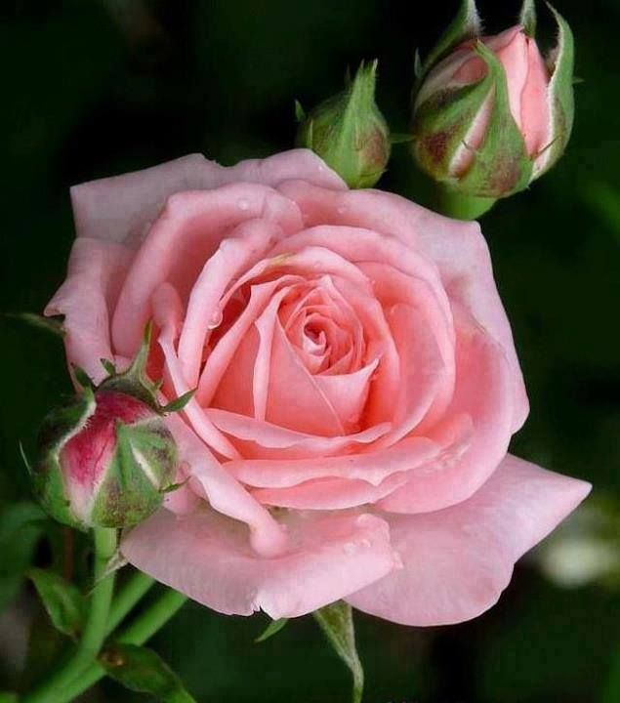

Roses, the epitome of elegance and romance, serve as the focal point of the decor in this enchanting birthday celebration. The venue is transformed into a floral wonderland, with roses adorning every corner, exuding timeless beauty and sophistication.

Upon entering the space, guests are greeted by a breathtaking display of roses cascading from ceiling installations, creating a sense of whimsy and enchantment. Soft petals in shades of blush, crimson, and ivory delicately unfurl, lending a touch of romance to the atmosphere.

Tables are adorned with exquisite rose centerpieces, each arrangement a work of art in its own right. Lush blooms spill from gilded vases, their heady fragrance infusing the air with a sense of opulence and grandeur. Candlelight dances among the petals, casting a warm, romantic glow over the scene and adding an element of intimacy to the festivities.